Setting up a Full-Fledged Mail Server on Ubuntu 20.04 with iRedMail For Contented-Academy.

What is iRedMail?
iRedMail is a shell script that automatically installs and configures all necessary mail server components on your Linux/BSD server, thus eliminating manual installation and configuration. With iRedMail, you can easily create unlimited mailboxes and unlimited mail domains in a web-based admin panel.

Step 1: Creating DNS MX Record :

You need to go to your DNS hosting service ( GODADDY ) to create DNS records. In your DNS manager, create a MX record for your domain name.

Step 2: Configuring Server & Ssh :

Log into your server via SSH, then run the following command to update existing software packages.

ssh -i "neonvir.pem" ubuntu@ec2-54-167-91-89.compute-1.amazonaws.com
sudo apt update
sudo apt upgrade -y
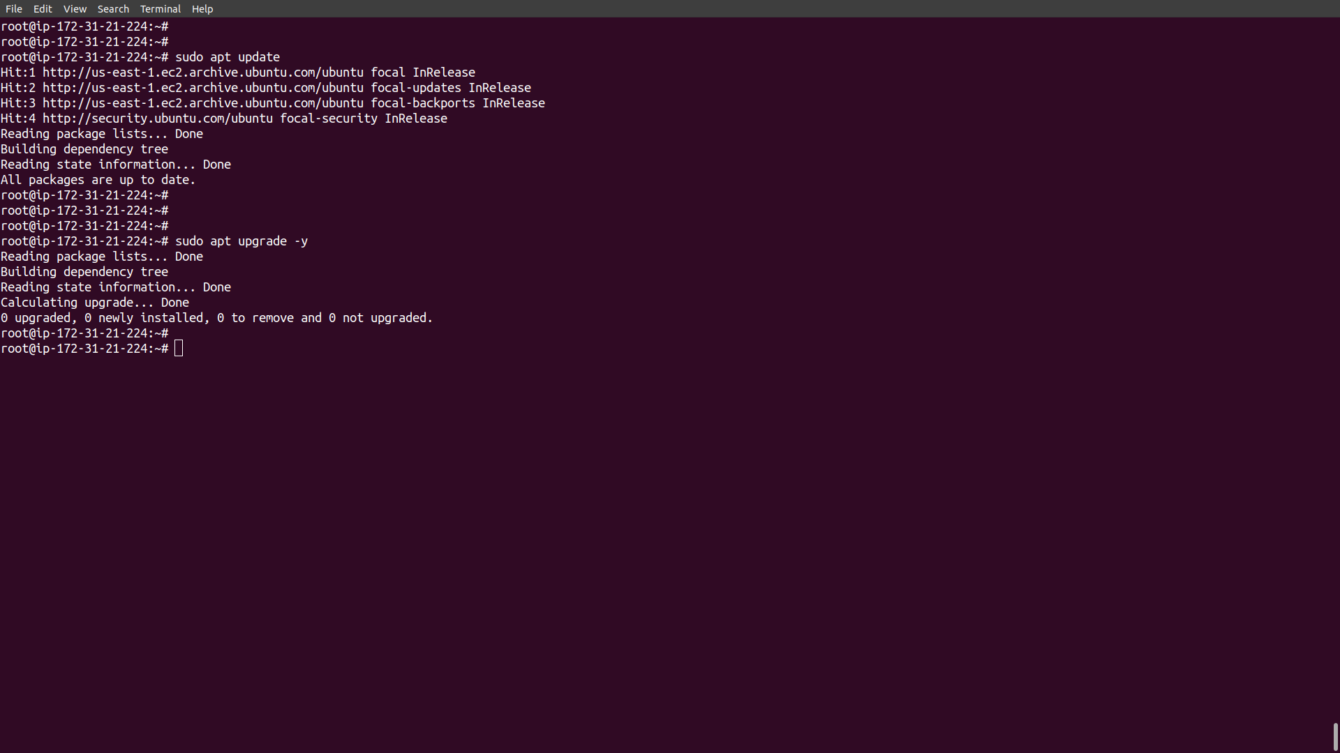

Step 3: Domain Configuration In Server :

Run the following commands to update the Domain Name with IP address.
We also need to update /etc/hosts file with a command-line text editor like Nano.

sudo nano /etc/hosts

Edit it like below. (Use arrow keys to move the cursor in the file.)
127.0.0.1 mail.contented.academy
Save the changes and close the file.

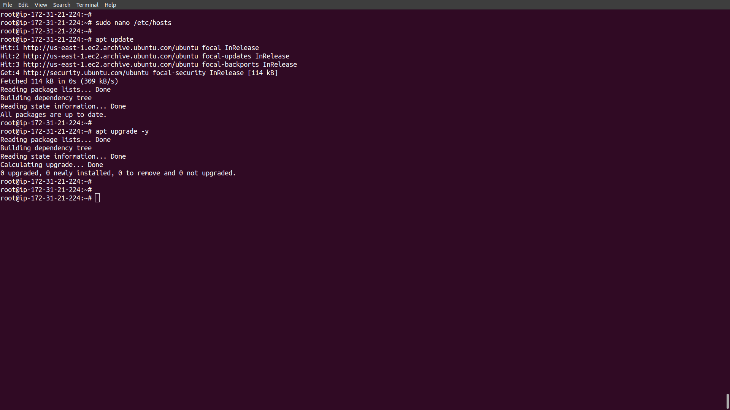
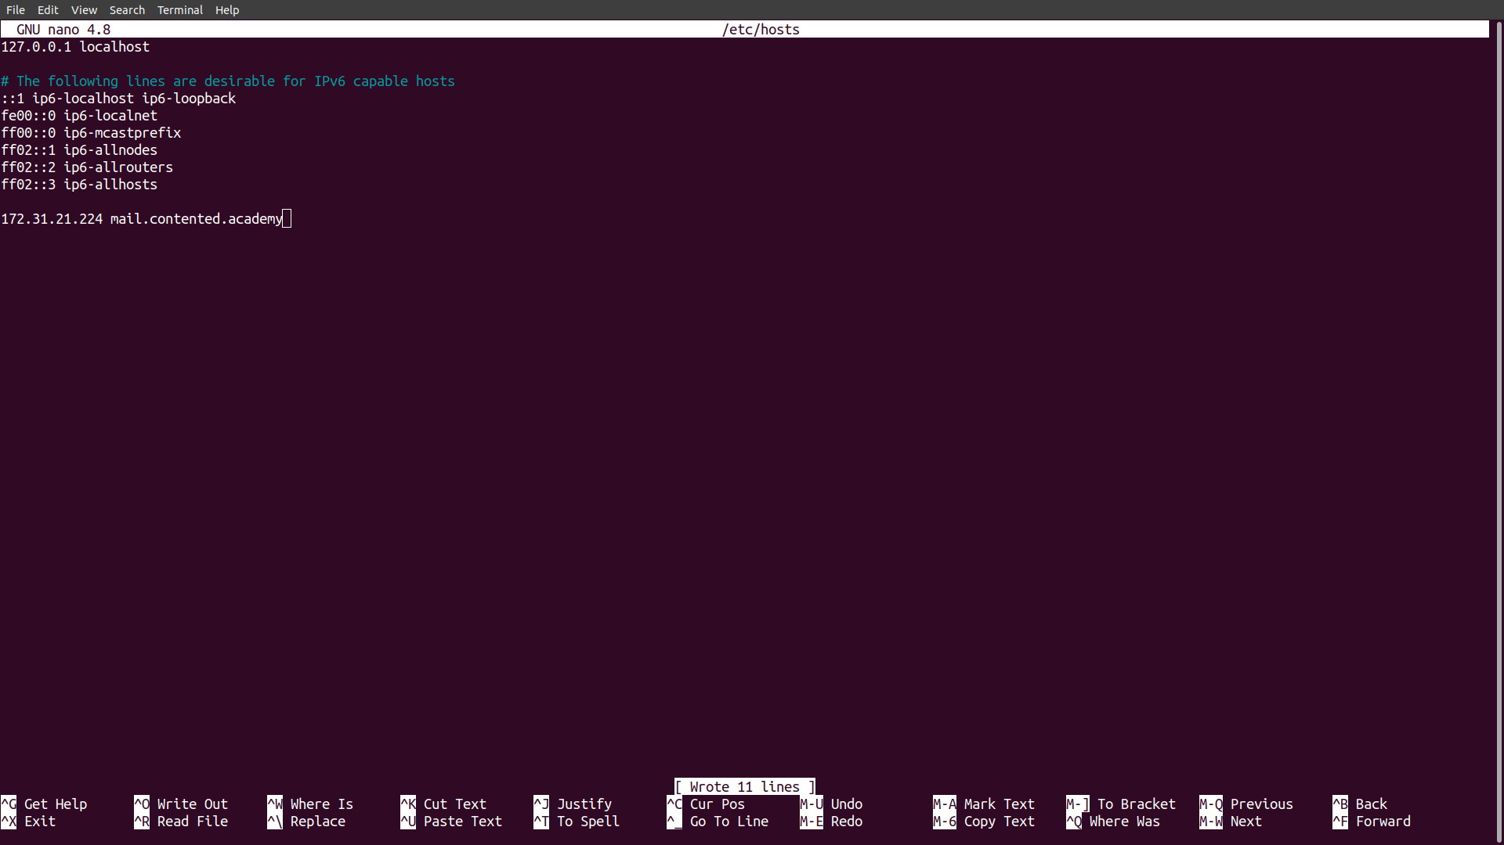

Step 4: Setting up Mail Server on Ubuntu 20.04 with iRedMail

Run the following commands to download the latest version of iRedMail script installer from its Github repository.

wget https://github.com/iredmail/iRedMail/archive/1.4.2.tar.gz

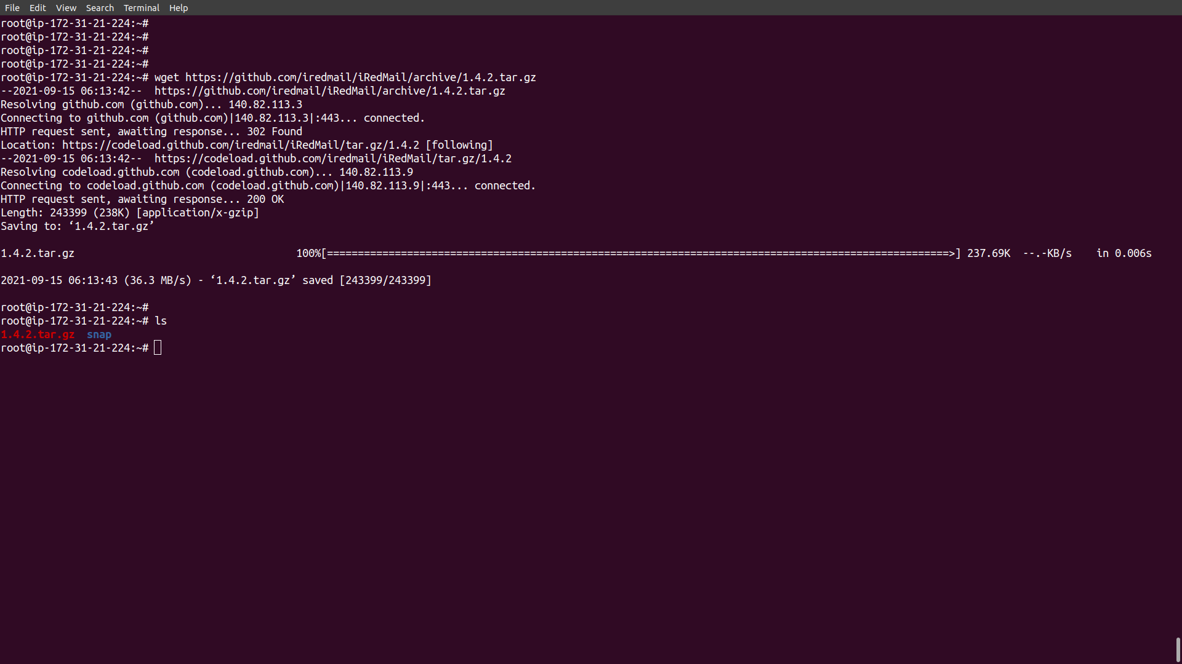

Extract the archived file.
tar xvf 1.4.2.tar.gz
Then cd into the newly-created directory.

cd iRedMail-1.4.2/

Add executable permission to the iRedMail.sh script.

chmod +x iRedMail.sh

Next, run the Bash script with sudo privilege.
sudo bash iRedMail.sh

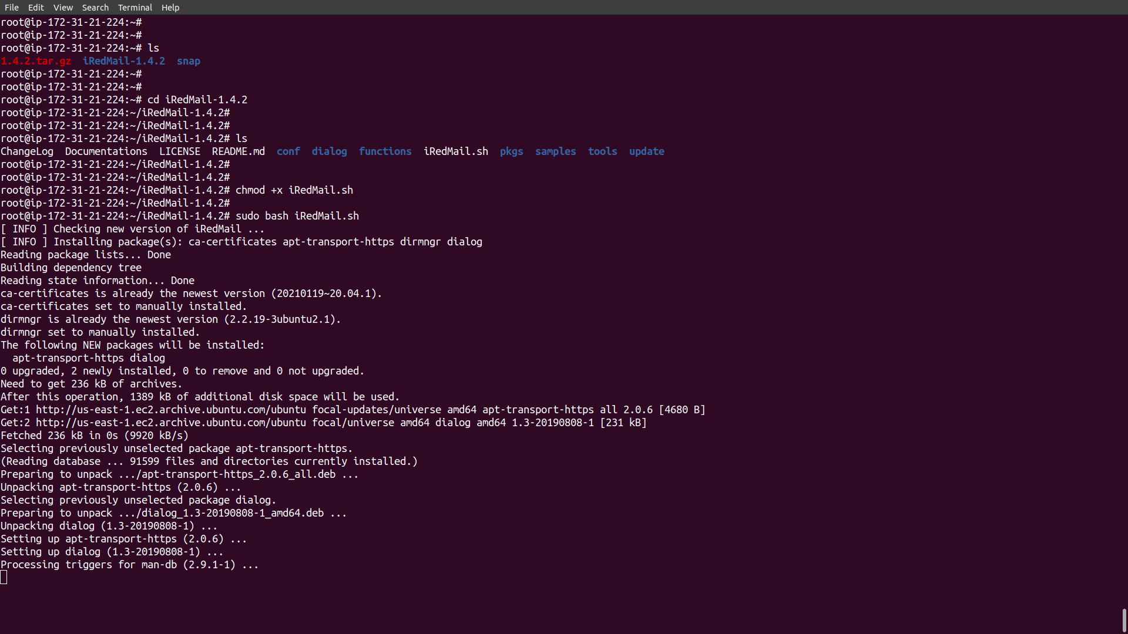

Step 5: The mail server etup wizard will appear. Use the tab key to select Yes & press Enter.

: The next screen will ask you to select the mail storage path. You can use the default path: /var/vmail, so simply press Enter.

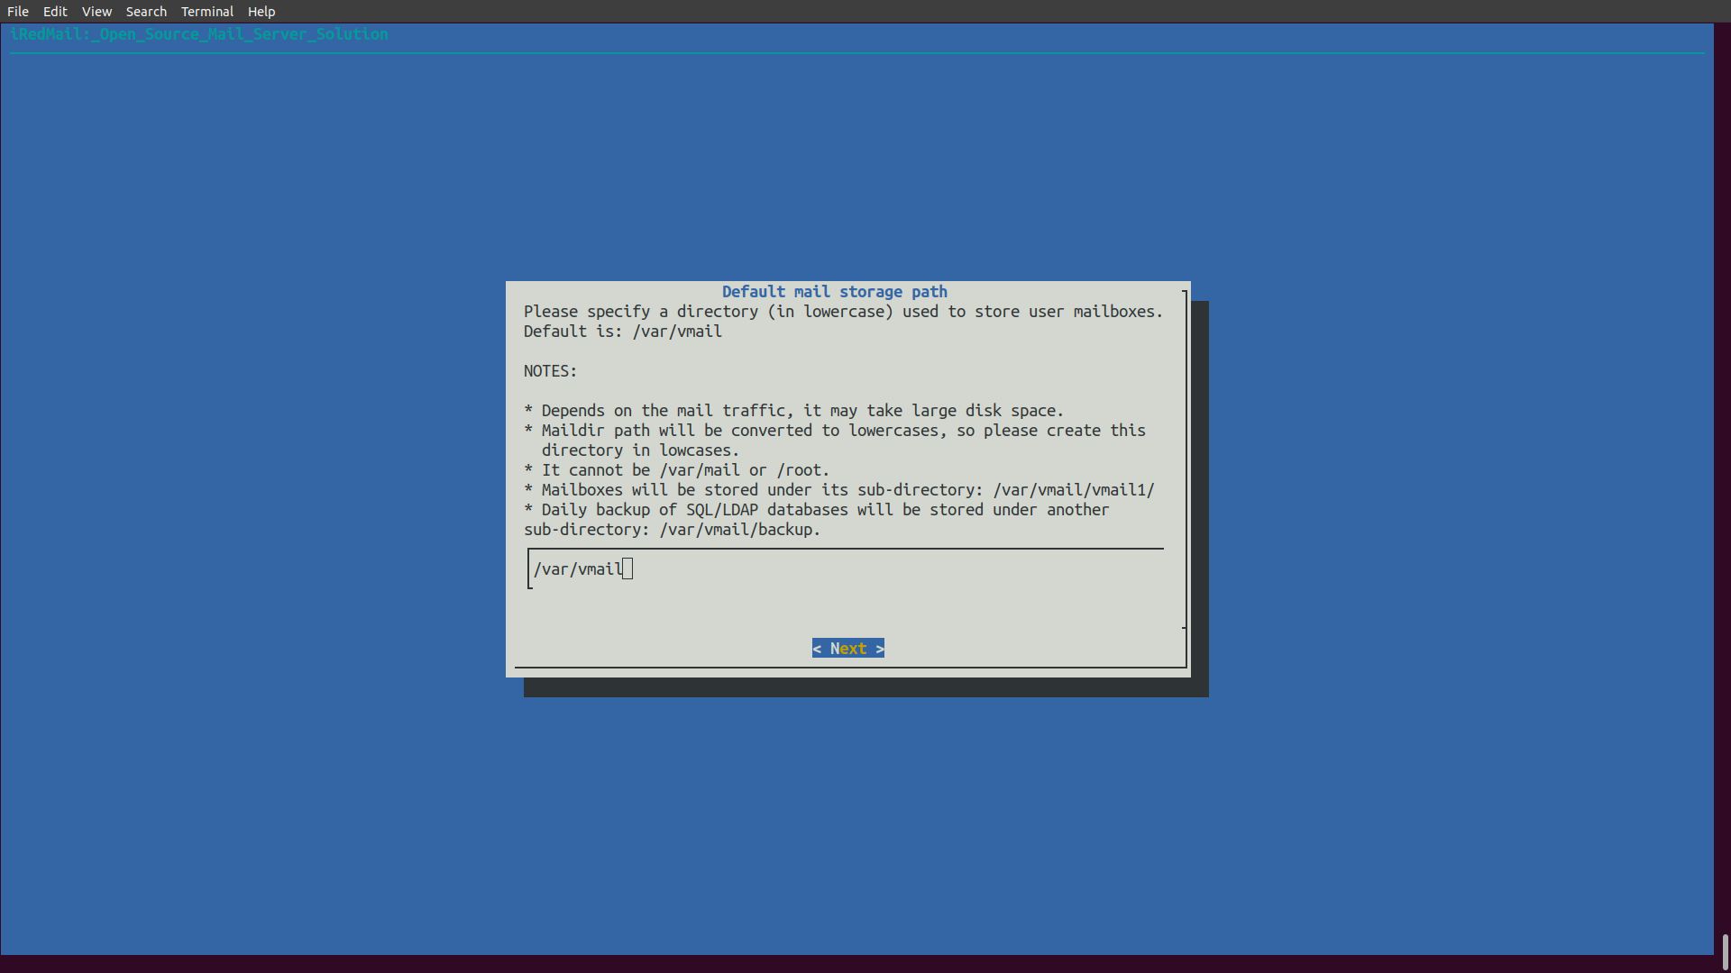

: Then choose whether you want to run a web server. It’s highly recommended that you choose to run a web server because you need the web-based admin panel to add email accounts. Also, it allows you to access the Roundcube webmail. By default, Nginx web server is selected, so you can simply press Enter. (An asterisk indicates the item is selected.)

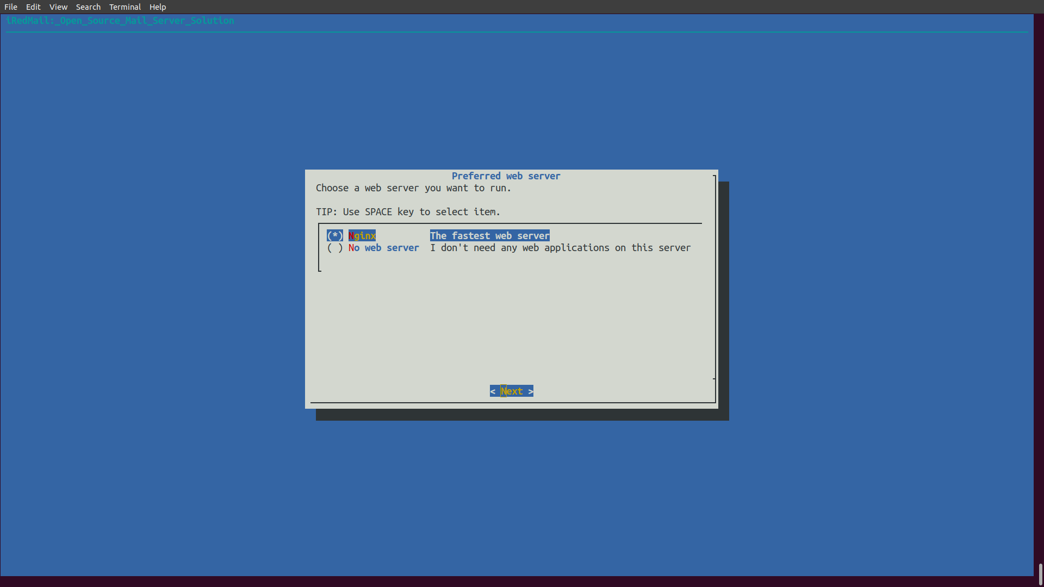
: Then select the storage backend for email accounts. Choose one that you are familiar with. This tutorial chose Postgre SQL. Press up and down arrow key and press the space bar to select.

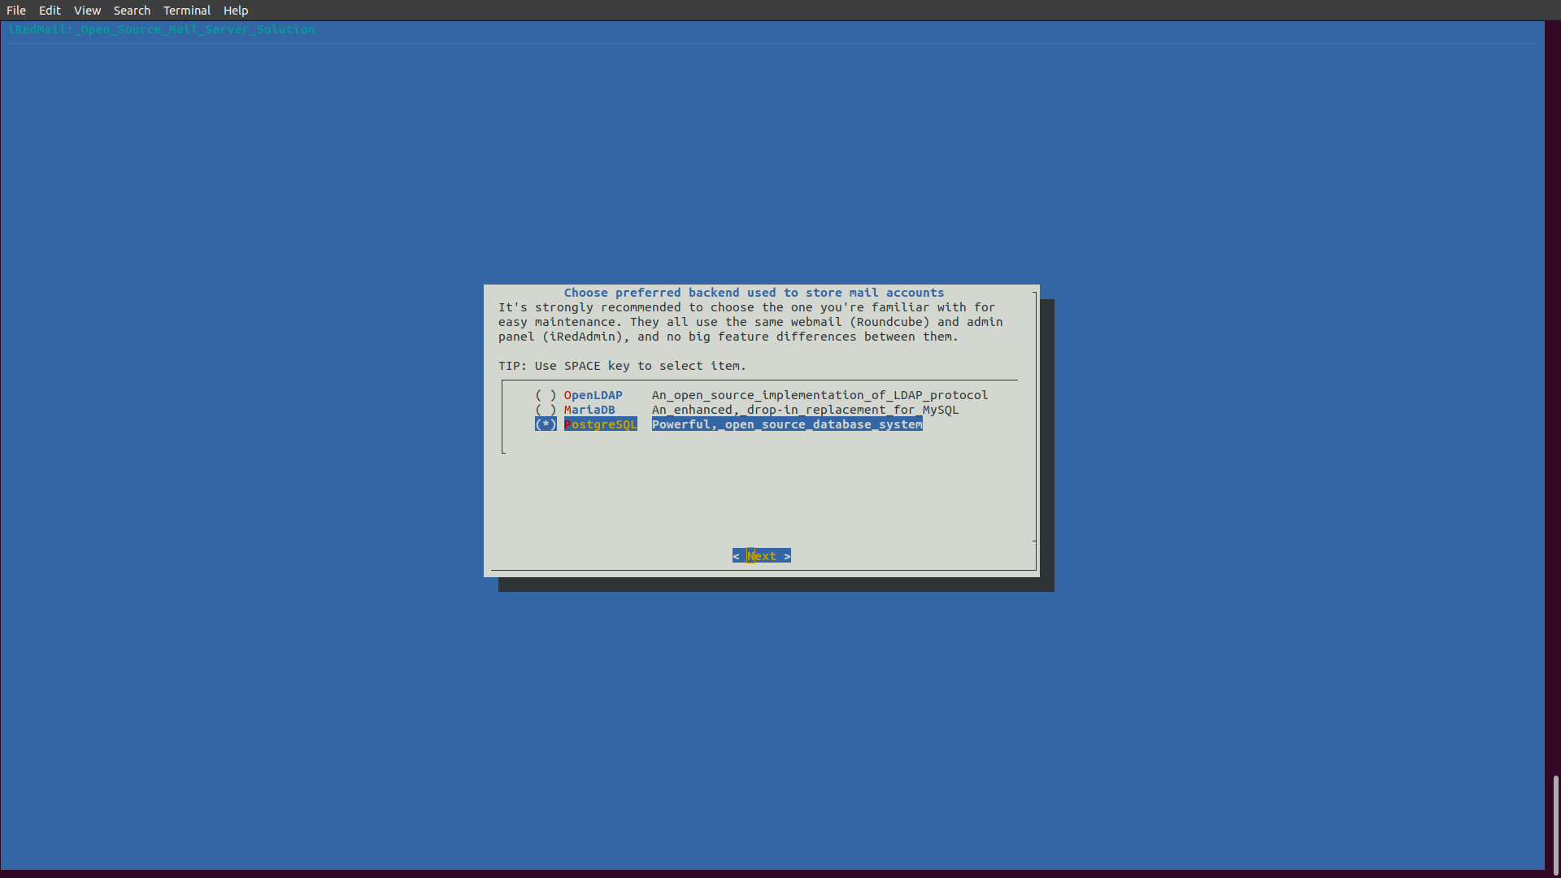
: If you selected PostgreSQL, then you will need to set the MySQL root password.

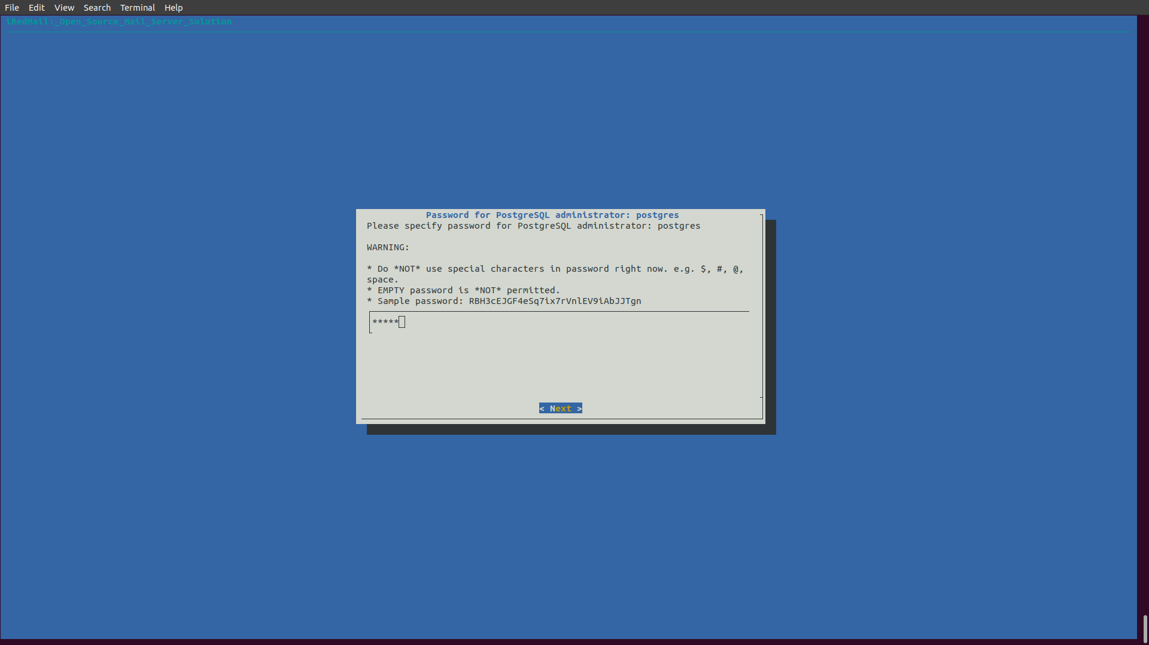

: Next, enter your first mail domain. You can add additional mail domains later in the web-based admin panel. This tutorial assumes that you want an email account like “mail.contented.academy” . In that case, you need to enter your-domain.com here, without sub-domain. Do not press the space bar after your domain name. I think iRedMail will copy the space character along with your domain name, which can result in installation failure.

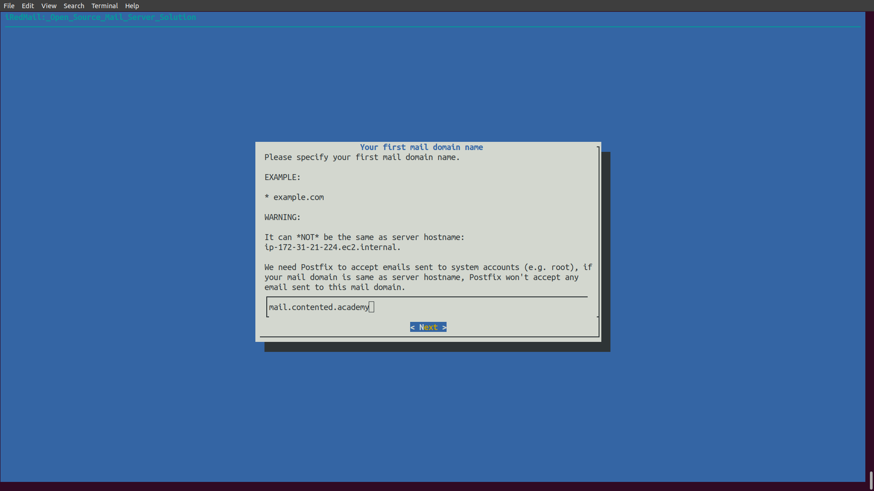
: Next, set a password for the mail domain administrator.
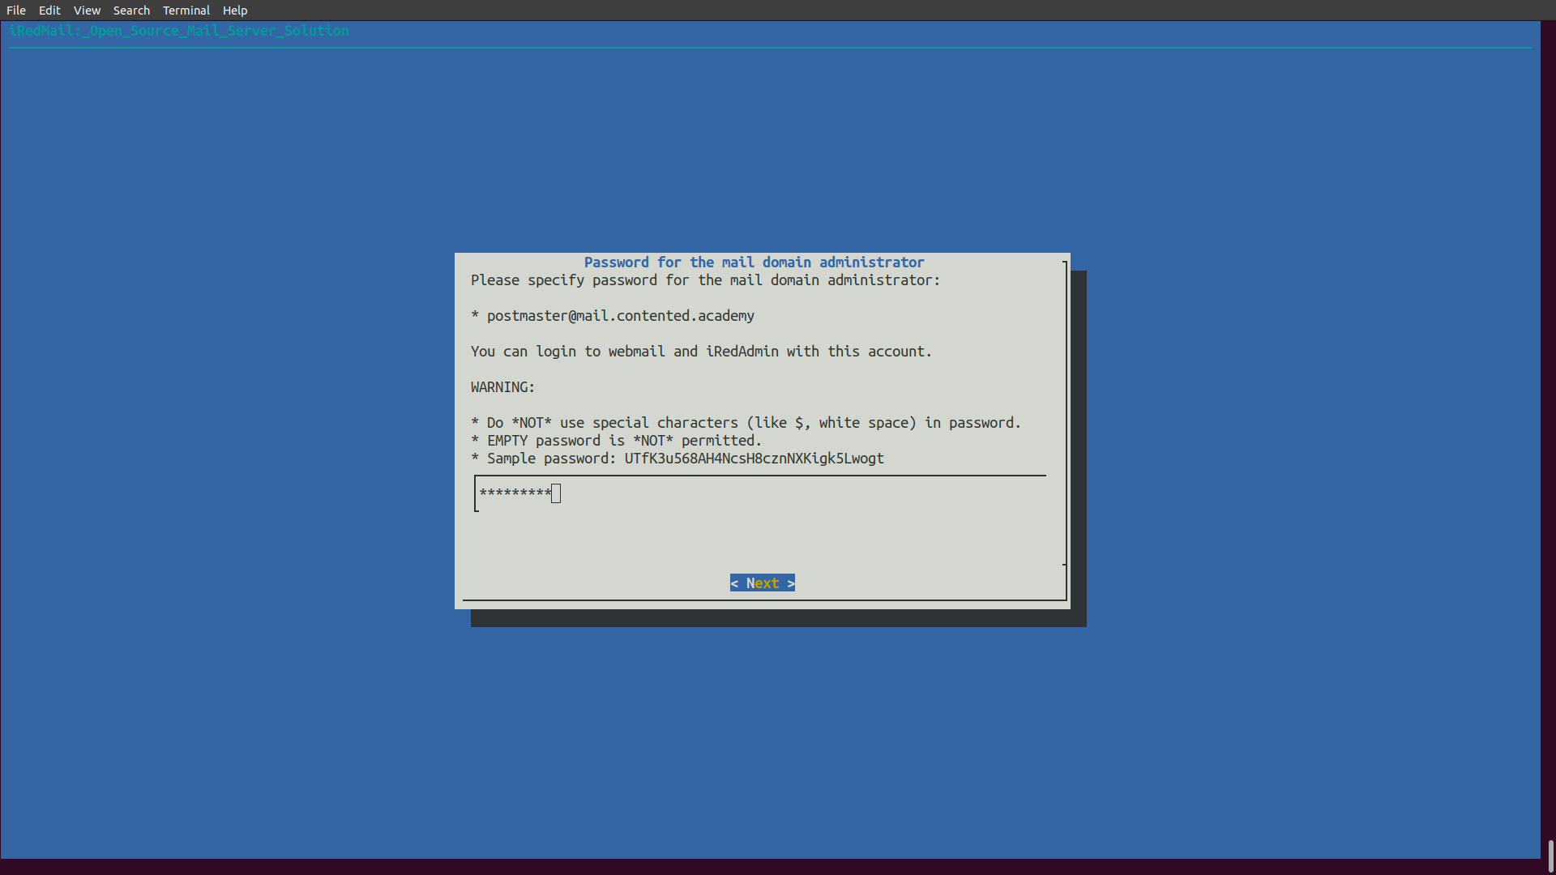

: Choose optional components. By default, 4 items are selected. If you like to use the SOGo groupware (webmail, calendar, address book, ActiveSync), then press the down arrow key and space bar to select. Press Enter to the next screen.

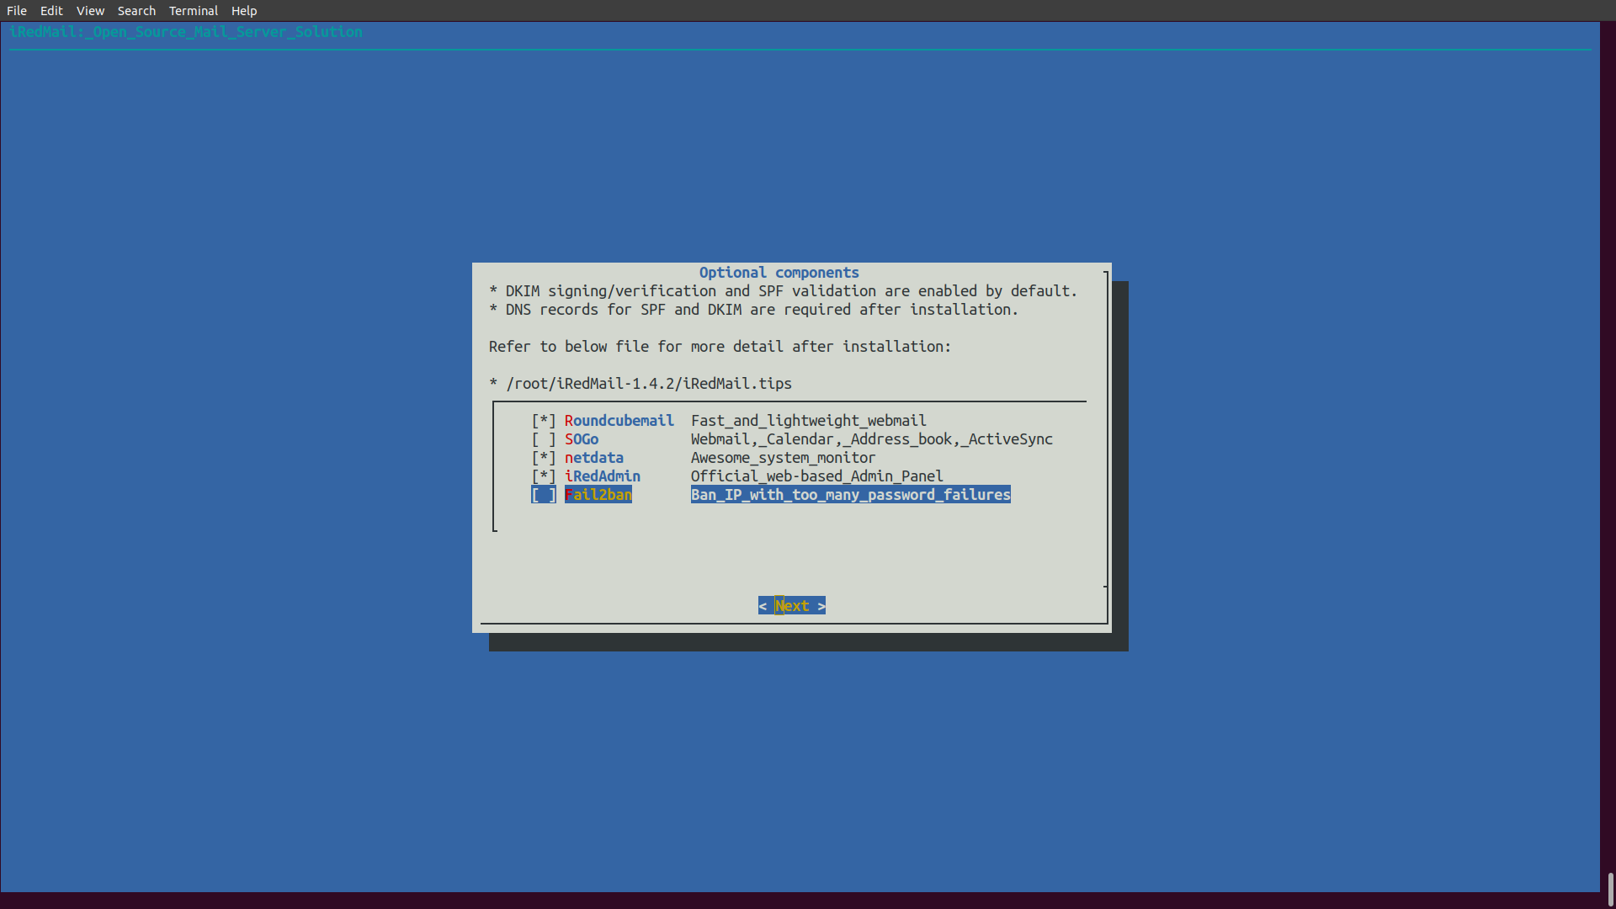

: Now you can review your configurations. Type Y to begin the installation of all mail server components.

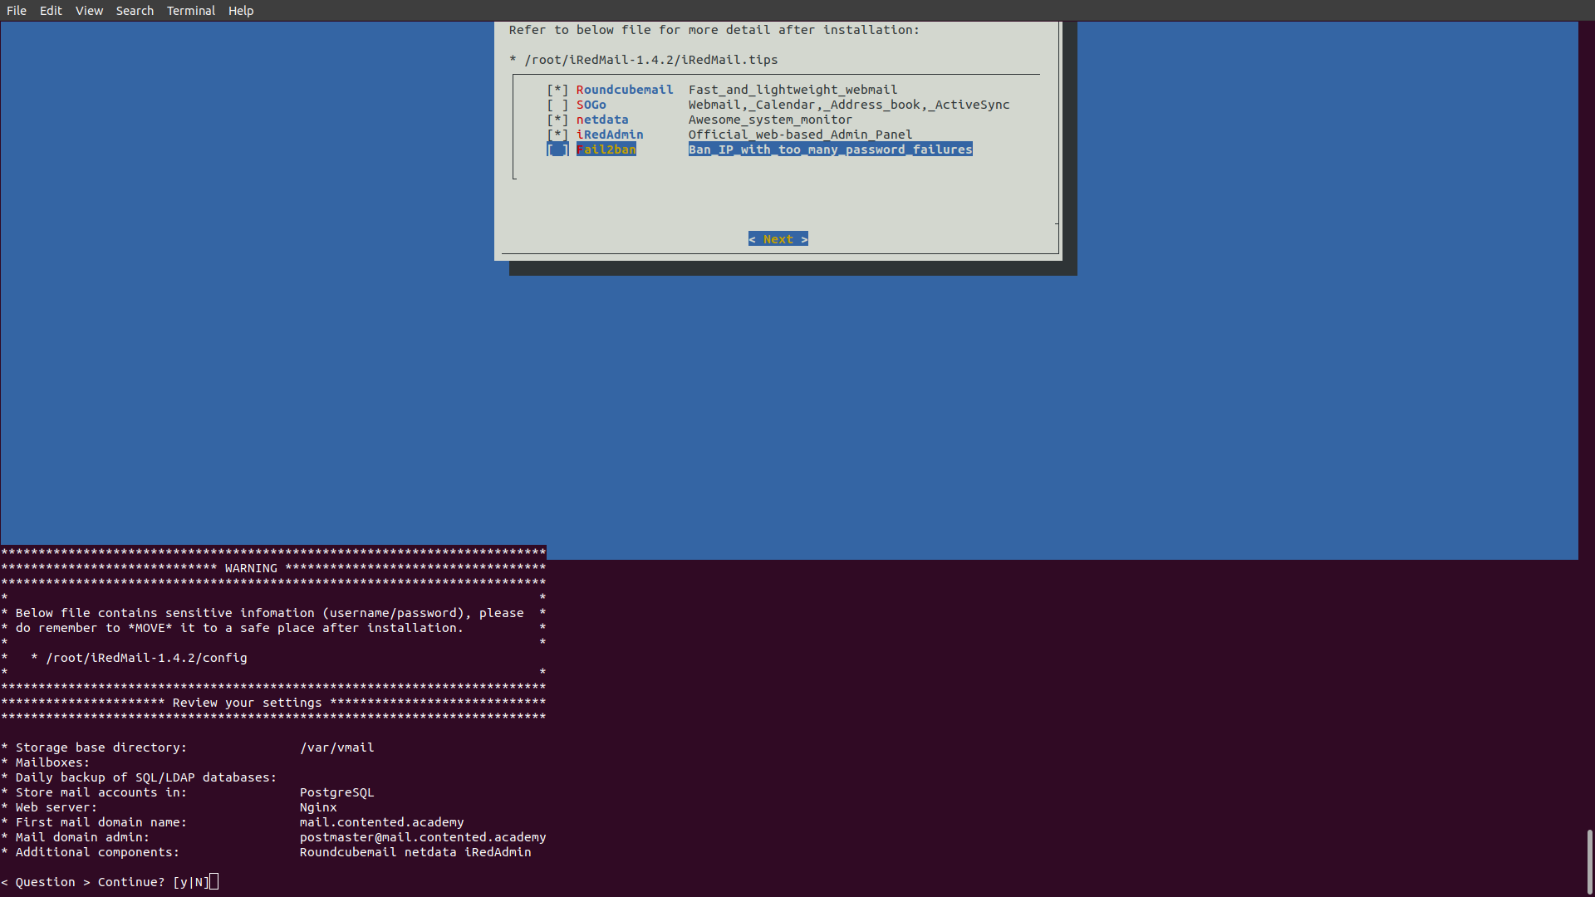

- Reboot your Ubuntu 20.04 server.

sudo shutdown -r now

- Once your server is back online, you can visit the web admin panel.
https://mail.conteted.academy/iredadmin/

